**Sam Son tour for 3 days 2 nights**

*Attention:*

-Departure point: Hanoi.

-Time: 3 days 2 nights.

-Media: car.

-Price: ~~2490000đ~~ to 1870000đ.

-Image:

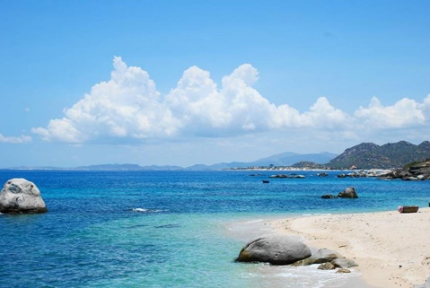 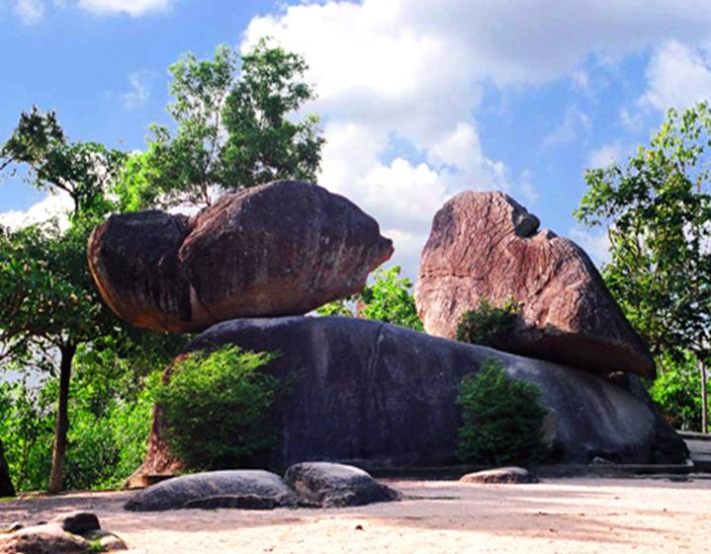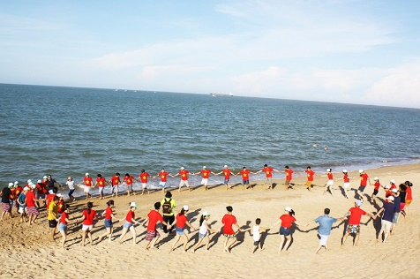

**I.Introduce:**

**Sam Son beach tour**

Nature has favored Sam Son land with many interesting and poetic beaches. Not only that, beside the sea is the towering Truong Le mountain. Together with coconut trees, casuarina ranges, Truong Le mountain has created Sam Son beach with wonderful moments when immersing in nature.

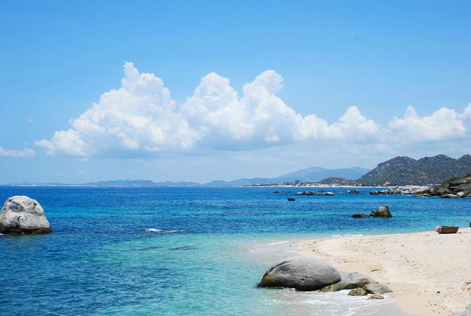

Sam Son beach at every moment of the day has different beauty. Sam Son when dawn, the sky blushed on the horizon, each fishing boat of the mountain village fishermen returned after a night of offshore fishing, bright smiles, full of happiness signaling a night sailed successfully. Sam Son seafood market is held right on the beach, with a rich source of seafood in Sam Son beach, visitors can choose and enjoy shrimp, crab, crab, squid, mackerel ... just recently beaten. caught in the night.

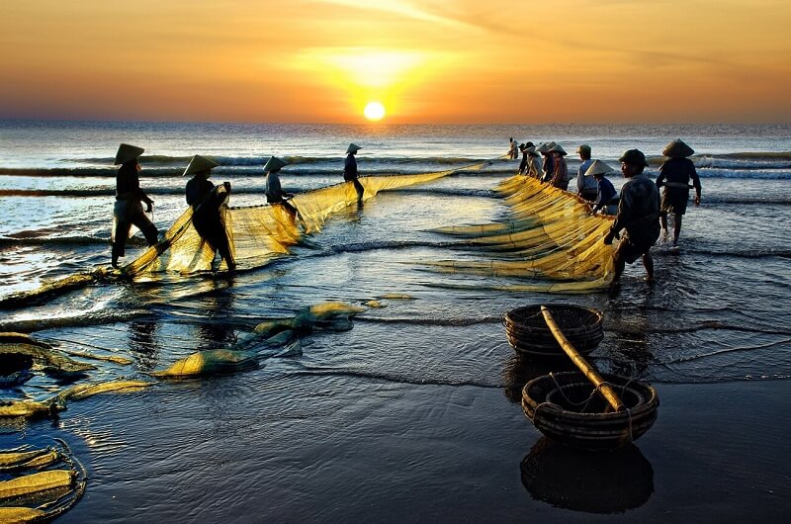

Sam Son beach with gentle golden sand, blue water, moderate salt concentration is suitable for human health. This is the ideal place to cool off in the hot summer.

**II.** **Tour schedule:**

**1.Dayy 1:**

HA NOI - SAM SON BEACH

_____________________________________________________________________

07h30: Car and guide Viet Center welcome guests at the meeting point of departure to Sam Son. On the way, rest and have breakfast at Phu Ly.

11h30: Go to Sam Son beach, have lunch at the restaurant with fresh seafood. Then check in hotel, rest.

Afternoon: Visit around town by tram. Freedom of Sam Son beach.

Evening: Have dinner, free to roam the coastal city at night.

Overnight at hotel.

_____________________________________________________________________

**2.Day 2:**

EXPLORE SAM SON BEACH

_____________________________________________________________________

06h30: Get up early to watch the sunrise on the sea. Have breakfast at Hotel. Car to take you to visit Co Tien Pagoda, Hon Trong Mai romantic romantic ... Lunch at the hotel.

Afternoon: You are free to swim Sam Son, have dinner and overnight at the hotel.

_____________________________________________________________________

**3.Day 3:**

SAM SON - HA NOI _____________________________________________________________________

Morning: Have breakfast, you go to Sam Son market freely to buy seafood, souvenirs. Lunch at the hotel.

12h00: Check out the room on the bus to Hanoi. On the way stop at Ham Rong bridge to buy local specialties as gifts.

17h30: Back to Hanoi, end the tour. Farewell and see you in the following programs!

_____________________________________________________________________

**III.** **INCLUDED AND TERMS:**

**Service includes:**

• Newer tourist cars, air-conditioned, shuttle to visit the program.

• 3-star hotel: Viet Hung / Bien Me, etc. or equivalent (standard of 02 people / room, if male or female paired with 3 guests).

• Eating meals program.

• 01 breakfast at the hotel

• 03 main meals, standard 150,000 VND / meal / meal.

• Professional tour guide, enthusiastic, thoughtful service throughout the trip.

• Travel insurance by day tour, the maximum compensation of 10,000,000 VND / case.

• Tourist hat, cold towels, drinks served on the tour.

**The service does not include:**

• Beverages: alcohol, beer, soft drinks and personal drinks not mentioned.

• Personal expenses: minibar, laundry, shopping, telephone, sightseeing, extra-program transportation and VAT.